Administrating Remote System
Tasks
1.Use ssh to connect from your Linux system to a remote server (you can use a free-tier cloud VM or a local VM). After connecting, create a directory named 'music_downloads' in your home folder on the remote server.

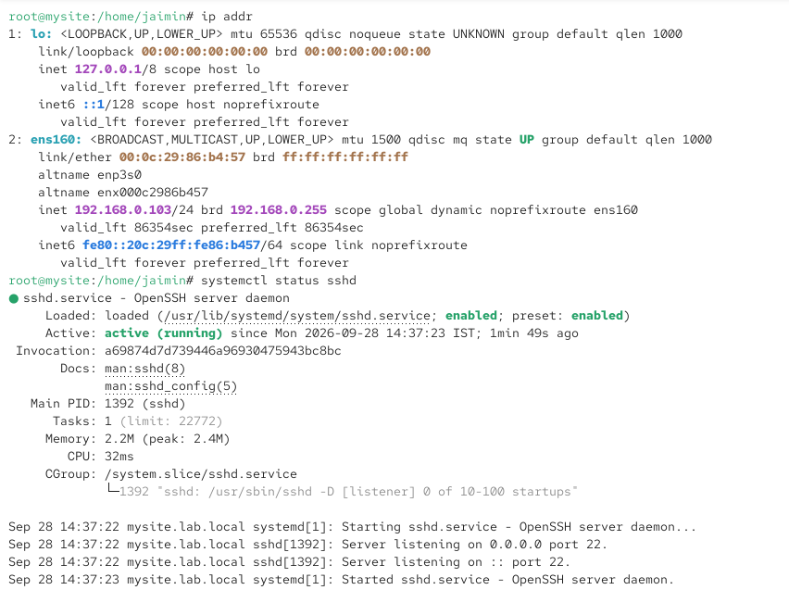

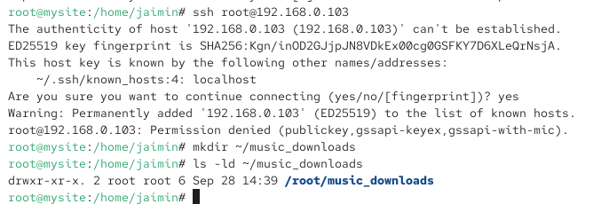
2.Transfer a file named 'playlist.txt' from your local machine to the remote server's 'music_downloads' directory using the scp command.Hint: Check the syntax for scp to specify both source and destination paths.

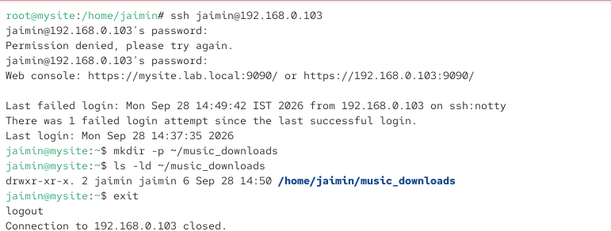
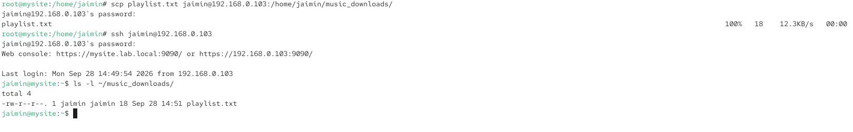

3.Set up passwordless SSH login from your local Linux system to the remote server by generating an SSH key pair and copying the public key to the remote server. Constraint: Do not use a passphrase for the key during this setup.

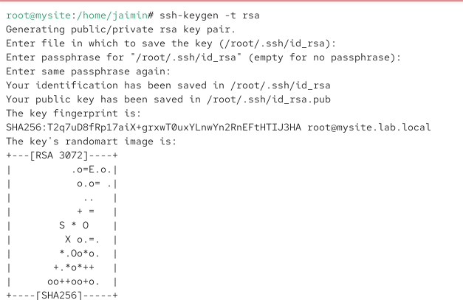
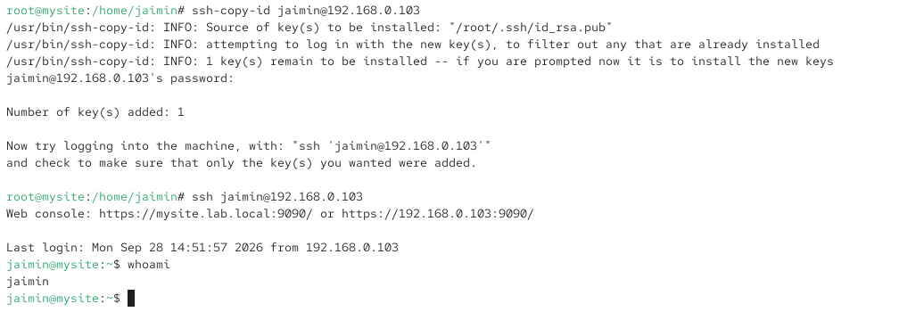

4.Simulate a Zomato-style admin task: Write a bash script on your local machine that uses ssh to remotely restart the 'nginx' service on the remote server and then checks its status. Save your script as 'remote_nginx_check.sh'.

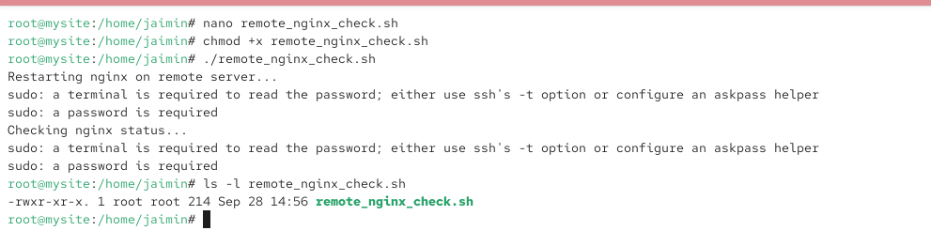
5.Find and fix the error in this ssh command: ssh user@192.168.1.100:/home/user/music_downloads Hint: Review the correct syntax for connecting to a remote server with ssh.
The given command is incorrect because SSH is used to connect to a remote server, not to specify a remote directory after the IP address.
Incorrect:
ssh user@192.168.1.100:/home/user/music_downloads
Correct SSH command:
ssh user@192.168.1.100
After connecting, go to the required directory:
cd /home/user/music_downloads
Explanation
The correct SSH syntax is:
ssh username@IP_address
The :/home/user/music_downloads format is used with commands such as scp for copying files, not with normal SSH login.

